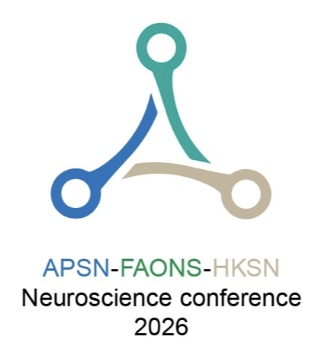 | Application for APSN-Young Investigator Colloquiums (YIC)

The APSN-FAONS-HKSN Neuroscience conference 2026, Cheung Kung Hai Conference Centre, the University of Hong Kong, Hong Kong, from August 23 to 26, 2026.

*Please submit the completed form to info@apsn-faons-hksn-2026.org

Name:
 | (Family Name) |  | (Other Name)
Country: |  |  | Institution
Affiliation & weblink
APSN Membership # |  | An awardee must be an APSN member by the time of the meeting, if not already a member. Please indicate membership status.
Title of Talk
Abstract (Maximum 300 words):

Significance of the topic (Maximum 200 words):

Brief CV (1-page)

List of representative publications (up to 10)

