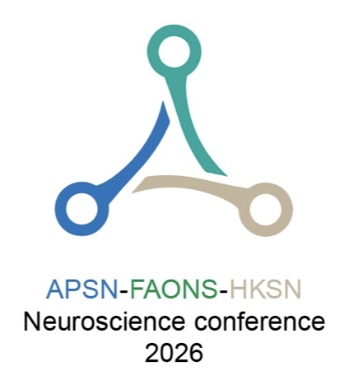 | Application for Symposium

The APSN-FAONS-HKSN Neuroscience conference 2026, Cheung Kung Hai Conference Centre, the University of Hong Kong, Hong Kong, from August 23 to 26, 2026.

*Please submit the completed form to info@apsn-faons-hksn-2026.org

Part A

- Topic of the Symposium

- Summary of proposal (maximum 300 words):

- Significance of the topic and proposal (max 200 words)

Part B : Names of the Chairperson and speakers

Chairperson
Name:
 | (Family Name) |  | (Other Name)
Country: |  |  | Institution
Affiliation & weblink
In the event that after the proposal is approved and there is/are changes to the speaker list, I am responsible to find a replacement speaker, subjected to the approval by the APSN-FAONS-HKSN 2026 Scientific Program Committee.

Signature:

Speaker 1
Name:
 | (Family Name) |  | (Other Name)
Country: |  |  | Institution
Affiliation & weblink

Speaker 2
Name:
 | (Family Name) |  | (Other Name)
Country: |  |  | Institution
Affiliation & weblink

Speaker 3
Name:
 | (Family Name) |  | (Other Name)
Country: |  |  | Institution
Affiliation & weblink

Speaker 4
Name:
 | (Family Name) |  | (Other Name)
Country: |  |  | Institution
Affiliation & weblink

Title of Talk 1
Speaker 1
Abstract (Maximum 300 words)
I approved the proposal and agreed to be included in the proposed symposium for the APSN-FAONS-HKSN Neuroscience Conference 2026.

Signature :
Title of Talk 2
Speaker 2
Abstract (Maximum 300 words)
I approved the proposal and agreed to be included in the proposed symposium for the APSN-FAONS-HKSN Neuroscience Conference 2026.

Signature :

Title of Talk 3
Speaker 3
Abstract (Maximum 300 words)
I approved the proposal and agreed to be included in the proposed symposium for the APSN-FAONS-HKSN Neuroscience Conference 2026.

Signature :

Title of Talk 4
Speaker 4
Abstract (Maximum 300 words)
I approved the proposal and agreed to be included in the proposed symposium for the APSN-FAONS-HKSN Neuroscience Conference 2026.

Signature :

